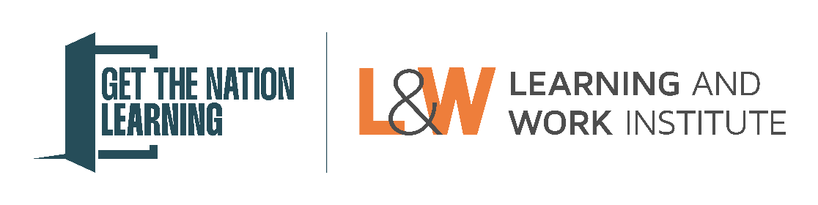
Get the Nation Learning Awards – Strategic Authority, Combined Authority, or Local Authority nomination form
Please note: Questions marked with a * are compulsory.
Section 1: Nominator details
First name *
Surname *

Job title *
Organisation name *

Please provide your telephone number and email address.
Work email address *
Work telephone number *

Please provide an alternative telephone number and email address should we not be able to reach you. This should be for an alternative person.
Alternative contact person name:
Alternative contact person job title:
Alternative contact person email address:
Alternative contact person phone number:

Section 2: Nomination details
Is your nomination for: *
A Strategic Authority, Combined Authority, or Local Authority

Name of Strategic Authority, Combined Authority, Local Authority *

Which award is your nomination for?
Please review the nomination guidance on the eligibility for each category and select the category your nomination is best suited to. L&W will consider your nomination for other eligible categories. *
Regional Growth

What region does your nomination relate to? Please select all that apply. *
East of England
East Midlands
London
North East England
North West England
South East England
South West England
West Midlands
Yorkshire and the Humber

Section 3: Nomination statement
You may find it useful to refer to the guidance when answering the questions below.
Please briefly describe the organisation you are nominating. This should include the organisation's purpose and its goals. (Maximum 50 words) *

Please provide an overview of what your nominated Strategic Authority, Combined Authority, or Local Authority has done to integrate adult learning into growth plans. (Maximum 300 words) *

Please provide a statement on why your nominated Strategic Authority, Combined Authority, or Local Authority should be considered for this award. This should include specific evidence on the impact of their learning strategy or provision on offer. (Maximum 300 words) *

Please include a statement from a resident, learner, or service user who has been impacted positively by the learning on offer. *

Section 4: Privacy and consent
Winners will be invited to an event to be presented with their award. They will have their photo taken and be asked to talk more about their impact or learning. Award winners often attract interest from local, regional and sometimes national press and media. We may want to share their story, images or interview with them to use in press releases. We may also contact them if there are additional publicity opportunities, such as interviews for radio or TV.
Considering the above, is there any information included in the nomination that you do not want to be made public? Please let us know below:

Please confirm the following:
The nominee has given permission for their information to be shared * | Yes / No
The nominee understands that their story will be shared in public communications and with the press and media * | Yes / No

Who would be the best person to liaise with regarding press and media interest?
Name *
Job title *
Email address *
Telephone number *

Please provide the name of a senior representative who you wish to be invited to the award ceremony as a guest.
Name *
Job title *
Email address *
Telephone number *

