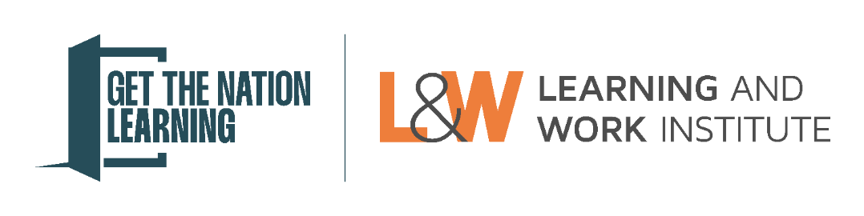

Information for learners nominated for an award

About Get the Nation Learning Awards
Get the Nation Learning is a campaign led by Learning and Work Institute. It aims to make and win the case for the importance of lifelong learning to people, our society and economy.
The Get the Nation Learning Awards are a central part of the campaign. As the biggest celebration of lifelong learning in England, they shine a light on people and organisations using adult learning to create healthier futures, stronger communities, more opportunities, and a thriving economy.

Being nominated for an award
Congratulations on being nominated for an award! The person nominating you thinks you deserve recognition for your achievements and that your story could inspire others.
We have answered some frequently asked questions below about what it means to be a nominated learner and how you can support the person nominating you.

What if I have a question that isn’t answered below?
If you have any questions, you can ask your nominator or contact the Get the Nation Learning team at getthenationlearning@learningandwork.org.uk. We will respond to emails as soon as possible (usually within two working days).

What is the process for being nominated?
Your nominator will complete an online form which tells us a bit about you, your learning, and your achievements. The form will ask them to include a statement from you. This should tell us about your learning experience and the difference it has made to your life in your own words.
Once the nomination form has been completed, your nominator will submit it to the Get the Nation Learning team. The final deadline for this is Thursday 4 June 2026.

What do I need to write about in my statement?
Your statement should provide an overview of the learning you have done, and why you should be considered for the award. This should include specific evidence of the difference learning has made to you and your life. This should be a maximum of 250 words.

Can I get help to write my statements?
Yes! You can get help from your nominator or someone else (for example a family member, friend, support worker, tutor) to help you write your statement.

When will I know if I have won an award?
We will notify all award winners and their nominators in July or August 2026.

What happens if I win an award?
If you are selected as an award winner, someone from the Get the Nation Learning team will contact you to let you know. We will announce award winners publicly at our ceremony at The Royal Society on Wednesday 4 November 2026. All award winners will be invited to the ceremony.
Between August and October 2026, we will prepare your story to include in our communications, for example on the Get the Nation Learning website and/or in the media. We will not share any information about you without your permission.

