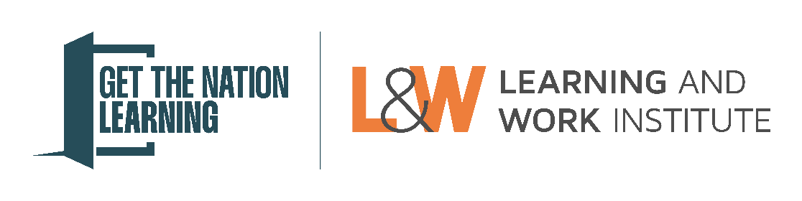
Get the Nation Learning Awards – Individual learner nomination form
Please note: Questions marked with a * are compulsory.
Section 1: Nominator details
First name *
Surname *

Job title *
Organisation name *

Please provide your telephone number and email address.
Work email address *
Work telephone number *

We expect to notify nominators of award winners in August 2025. If you will be unavailable for all or a significant part of this time, please provide an alternative person we can contact in your absence.
Alternative contact person name:
Alternative contact person job title:
Alternative contact person email address:
Alternative contact person phone number:

Section 2: Nomination details
Is your nomination for: *
A learner

Which award is your nomination for?
Please review the nomination guidance on the eligibility for each category and select the category your nomination is best suited to. L&W will consider your nomination for other eligible categories. *
Healthier Futures
New Directions
Net Zero Hero
Patron’s

What region does your nomination relate to? Please select all that apply.*
East of England
East Midlands
London
North East England
North West England
South East England
South West England
West Midlands
Yorkshire and the Humber

Name of nominated learner
Name *
Name as it should appear on any award or certificate *

Please provide the nominated learner’s age (include an approximate age if needed)
Age *

Section 3: Nomination statement
Please provide an overview of the learning your nominee has done, linking this to the criteria included in the guidance document for this award. (Maximum 300 words) *

Please provide a statement on why your nominated learner should be considered for this award. This should include specific evidence on the impact that their engagement with learning has had, linked to the criteria included in the guidance document for this award. (Maximum 300 words) *

Please include a statement from the learner you are nominating. This should support the statement you have made above and show the impact of the learning they have engaged in. (Maximum 250 words) *

Section 4: Privacy and consent
Winners will be invited to an event to be presented with their award. They will have their photo taken and be asked to talk more about their impact or learning. Award winners often attract interest from local, regional and sometimes national press and media. We may want to share their story, images or interview with them to use in press releases. We may also contact them if there are additional publicity opportunities, such as interviews for radio or TV.
Considering the above, is there any information included in the nomination that you do not want to be made public? Please let us know below:

Who would be the best person to liaise with regarding press and media interest? This may be an organisation’s press/marketing team or another appropriate person.
Name *
Job title *
Email address *
Telephone number *

Please provide the name of a senior representative (CEO, Director etc) who you wish to be invited to the award ceremony as a guest. Please note that not all those put forward will be invited.
Name *
Job title *
Email address *
Telephone number *

